**PHP**

**PROGRAMMING**

**PROJECT**

**MCQ-Examination System**

## 

|  |  |  |
| --- | --- | --- |
| **Sr. No.** | **Heading** | **Page No.** |
| 1 | Abstract of Project | 3 |
| 2 | Objective of Project | 3 |
| 3 | Scope of Project | 4 |
| 4 | Key Features | 4 |
| 5 | Design Model | 4 |
| 6 | ER Model Diagram | 5 |
| 7 | Use Case Diagram | 6 |
| 8 | Data Flow Diagram | 7 |
| 9 | Test Cases | 8 |
| 10 | Project | 10 |

***Abstract of Project***

This project will overcome the time consuming problem of manual system. Apart from that in current system, checking the answer sheets after taking test, waste the examiners time, so this application do all these works in effective manner. The users who don’t have high computing knowledge they also can use this applications as it’s user-friendly and has a documentation. The conclusion of this project will be that it saves a lot of time of Examiner and will be more efficient and effective in conducting and managing quizzes. Examiner will be able to have a proper look at the data and it will become easy to get a summary out of the quiz.

***Objective of Project***

Due to pandemic the educational institutes have shifted to online platforms for conducting daily lectures and exams. There is a need of a quick and easy to use Online MCQ Conducting Platform. This Project will make it easy to conduct tests for ones who don’t have a good technical experience. It is not easy to conduct test on online software like Google Forms, Testmoz, etc. nowadays. They are not easy to use and it takes a lot of time for the users who have just started using it. So I have designed a MCQ Platform which makes it easy for conducting and managing MCQ Exams. It will include from taking a Quiz from examiner, making it available for students in particular period of time, saving the information of all participants, showing data statistically for have a clear look at the picture, showing results to each participant, etc. This application will work more effective than manual systems and will save a lot of time.

***Scope of Project***

1. Able the examiners to upload the MCQ questions online.
2. Able the users to solve the questions online.
3. Examiners can manage the information regarding exam.
4. Correct answers will be evaluated by system.
5. Users can see their result after submitting the test.
6. Data is shown in Statistical format so Examiner can have summarized view of the results.

***Key Features***

1. Easy to Use.
2. Can handle a lot of users at a time.
3. Record malpractices.

4.) Multiple result view for Examiner to have the best view over the progress of students.

5.) Secure, faster and more efficient than Manual Systems.

***Design Model***

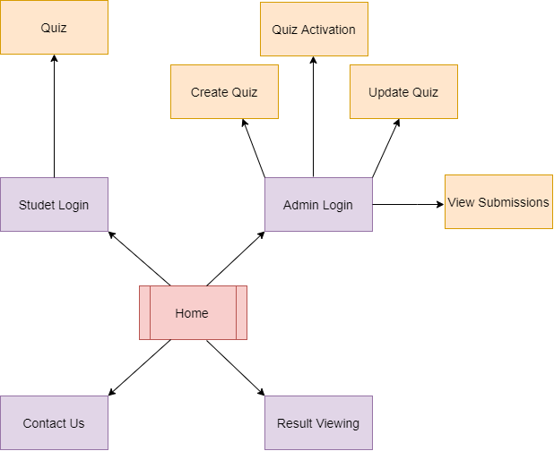

***ER Model Diagram***

ER model stands for an Entity-Relationship model. It is a high-level data model. This model is used to define the data elements and relationship for a specified system. It develops a conceptual design for the database. It also develops a very simple and easy to design view of data.

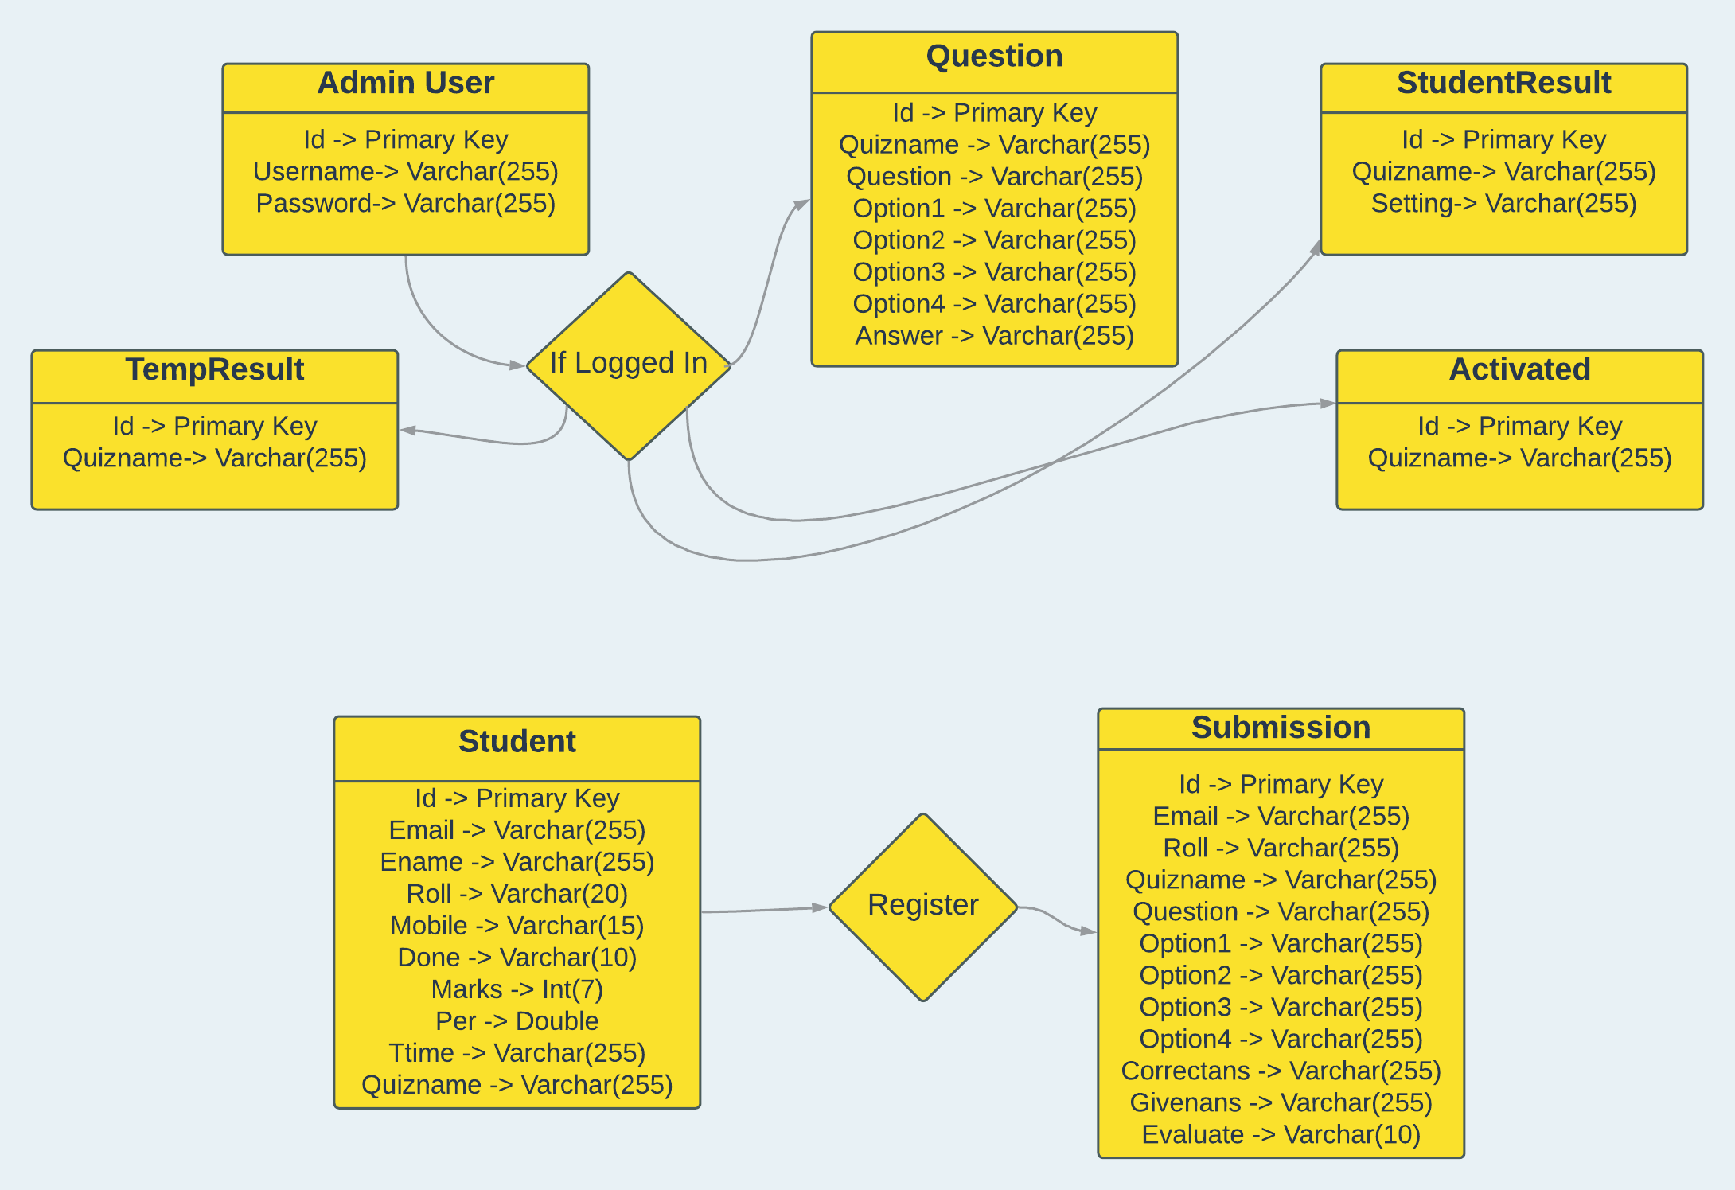

***Use Case Diagram***

In UML, use-case diagrams model the behavior of a system and help to capture the requirements of the system. Use-case diagrams describe the high-level functions and scope of a system. These diagrams also identify the interactions between the system and its actors. UML diagrams can be used as a way to visualize a project before it takes place or as documentation for a project afterward. But the overall goal of UML diagrams is to allow teams to visualize how a project is or will be working, and they can be used in any field, not just software engineering.

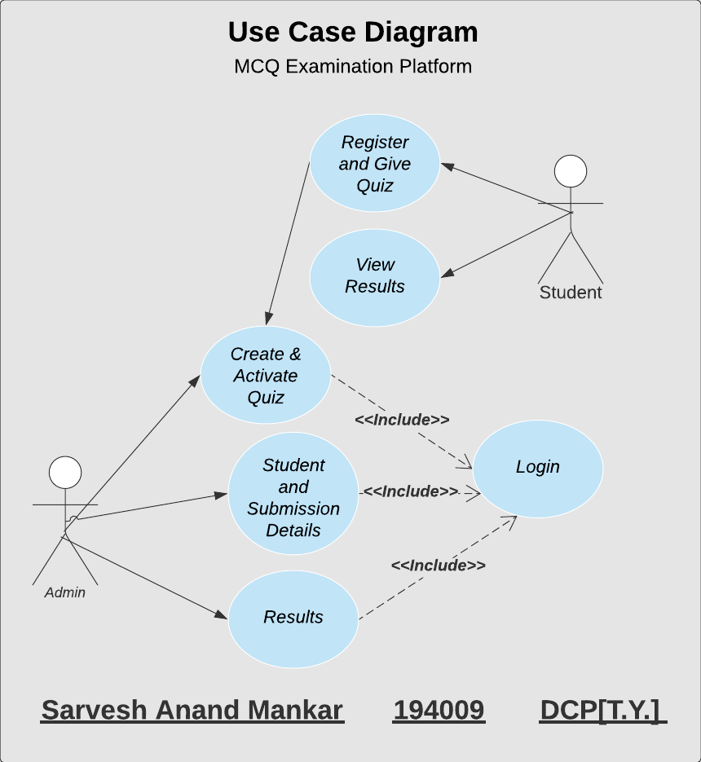

***Data Flow Diagram***

The DFD level 0 gives the brief idea about the software system by Specifying the general functions performed. It has both input and output for main process.

The DFD level 1 describes in detail the main process, all its functions that carried out and also the input provided with the output generated.

The DFD level 2 describe the process which is main in the level 1.

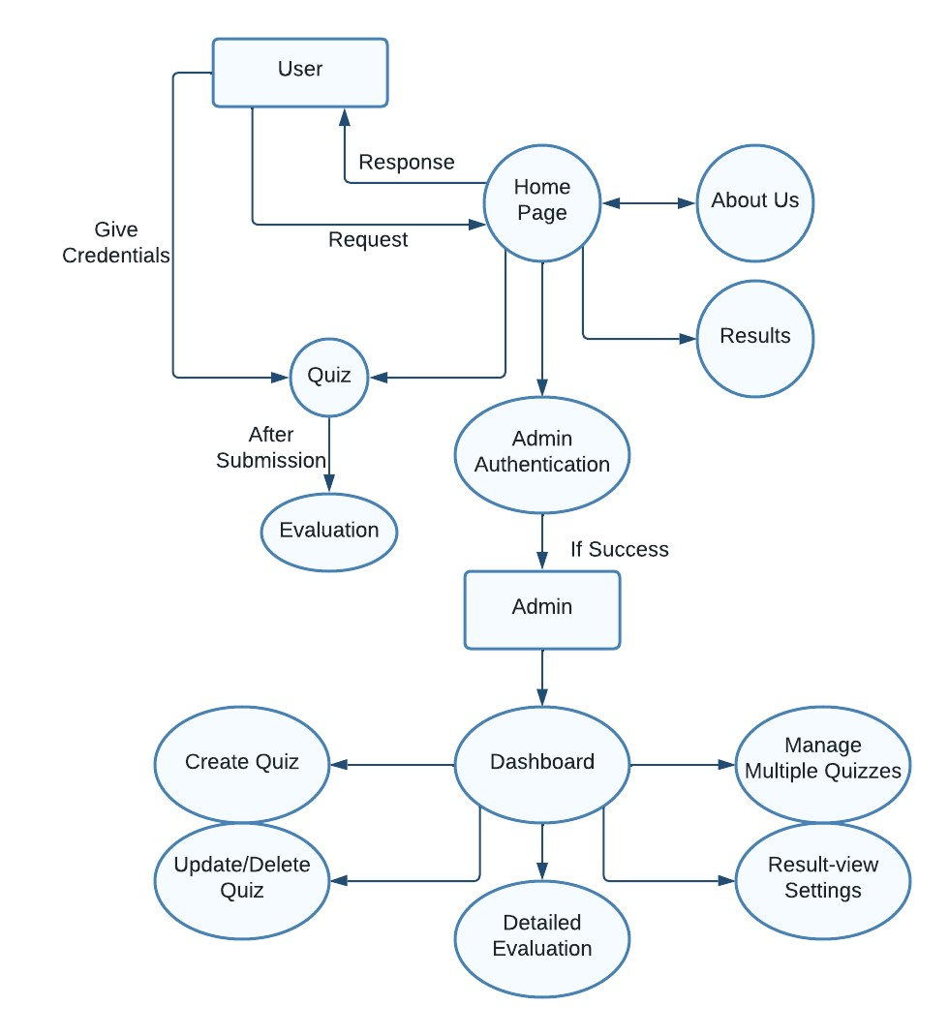

***Test Cases***

|  |  |  |  |
| --- | --- | --- | --- |
| Test Case ID | Test Case Description | Test Case Steps and Test Input | Expected Output |
| Test - 01 | This test case would check for a **valid** Username and Password in Admin Login Form. | Open Login Form, enter the username as **Sam** and password as **Sam1234.** | Will be redirected to the Dashboard of Quiz Examination Platform. |
| Test - 02 | This test case would check for an **invalid** Username and Password in Admin Login Form. | Open Login Form, enter the username as **Sam** and password as **Sarvesh123.** | Login Access will be denied and user will be redirected to Admin Login Form. |
| Test - 03 | This test case would create a Quiz, with Quiz name already existed. | The Admin will give Quiz name which already existed. | The message will be displayed to choose another quiz name. |
| Test - 04 | This test case would create a new Quiz. | Admin will set the Question Paper with all questions, their 4 Options and Answers. | A quiz will be created which can be displayed in the **Show Quiz** Page for Admin. |
| Test - 05 | This test case would update a particular existing Quiz. | Admin will make the required changes in the selected quiz. | Changes will be applied. Updated Quiz is displayed in the **Show Quiz** Page for Admin. |
| Test - 06 | This test case would Delete an Existing Quiz. | Admin will select a quiz which is to be deleted from a list from Dashboard. | The Quiz will be deleted. |
| Test - 07 | This test case would Activate the required quiz for Students. | Admin will select a quiz which is to be activated from a list from Dashboard. | The Quiz Questions will be visible for the Students and submissions will be evaluated and saved. |
| Test - 08 | This test case would Deactivate the required quiz for Students. | Admin will select a quiz which is to be deactivated from a list from Dashboard. | The Quiz will not be visible for the Students. |
| Test - 09 | This test case would Deactivate all quizzes for Students. | Admin will click on **Deactivate All Quizzes** button. | None of the Quiz will be visible for Students. |
| Test - 10 | Register and will allow student to give Quiz if he/she is giving that quiz for the first time. | Give the Personal Information. | Quiz is displayed and student can submit it. |
| Test - 11 | This test case would Register and will allow student to give Quiz if he/she has already given it. | Entered the roll no. or email which has been already used for submission in this quiz. | Not allow student to submit the quiz again. |
| Test - 12 | This test case would show detailed Results of quiz in Tabular and Graphical Format. | Admin selects the quiz name from a given list of quizzes. | All submission are visible and Admin can select the format in which he wants to study the data. |
| Test - 13 | This test case would set Result View Setting for Student. | Admin selects the settings in which a student should see the results of particular quiz. | Student is able to see the results in the way in which admin wants. |

***Project***

Source Code Link:-

<https://github.com/SarveshMankar/MCQ-Examination/>

Admin Login

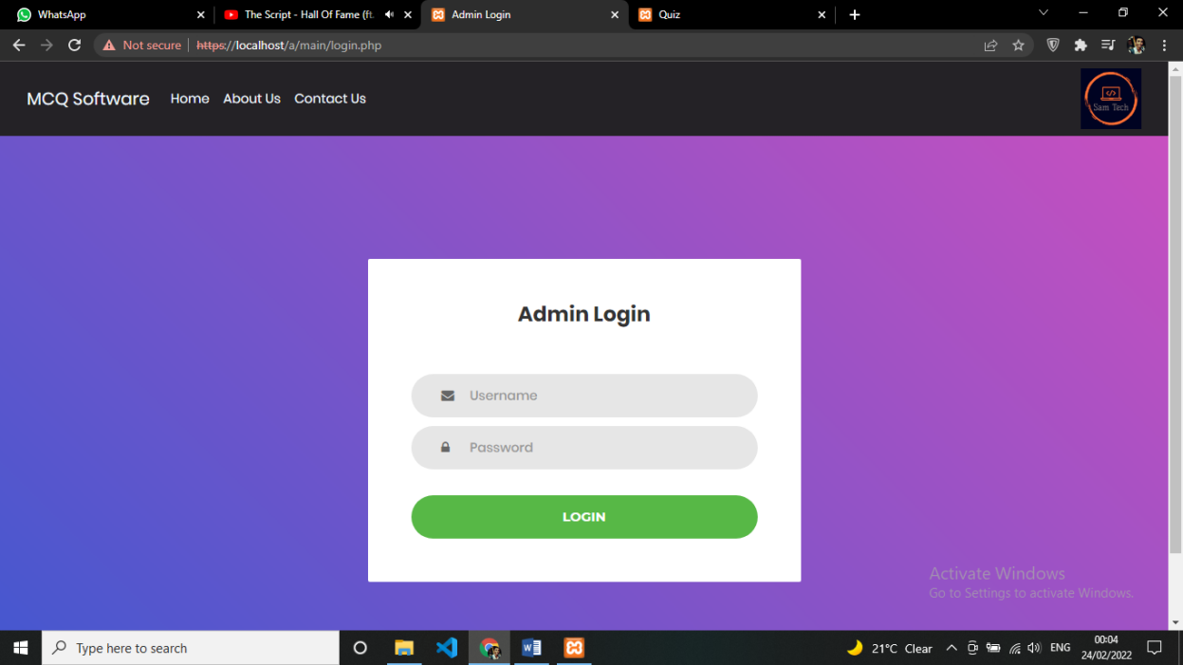

Quiz Registration

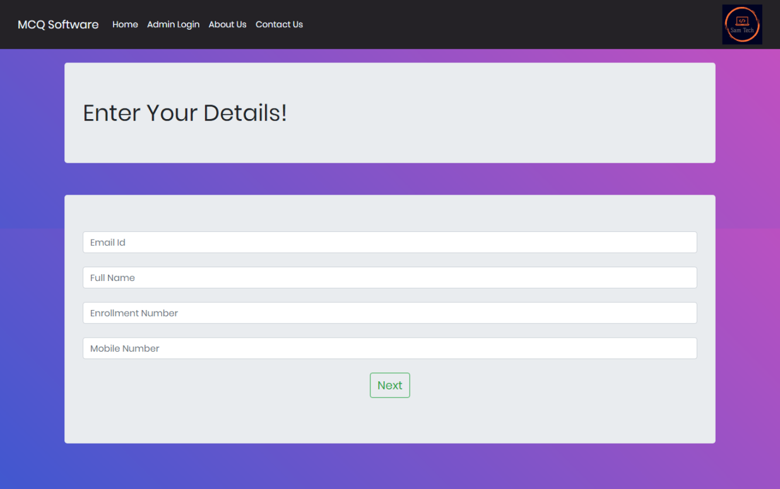

Admin Dashboard

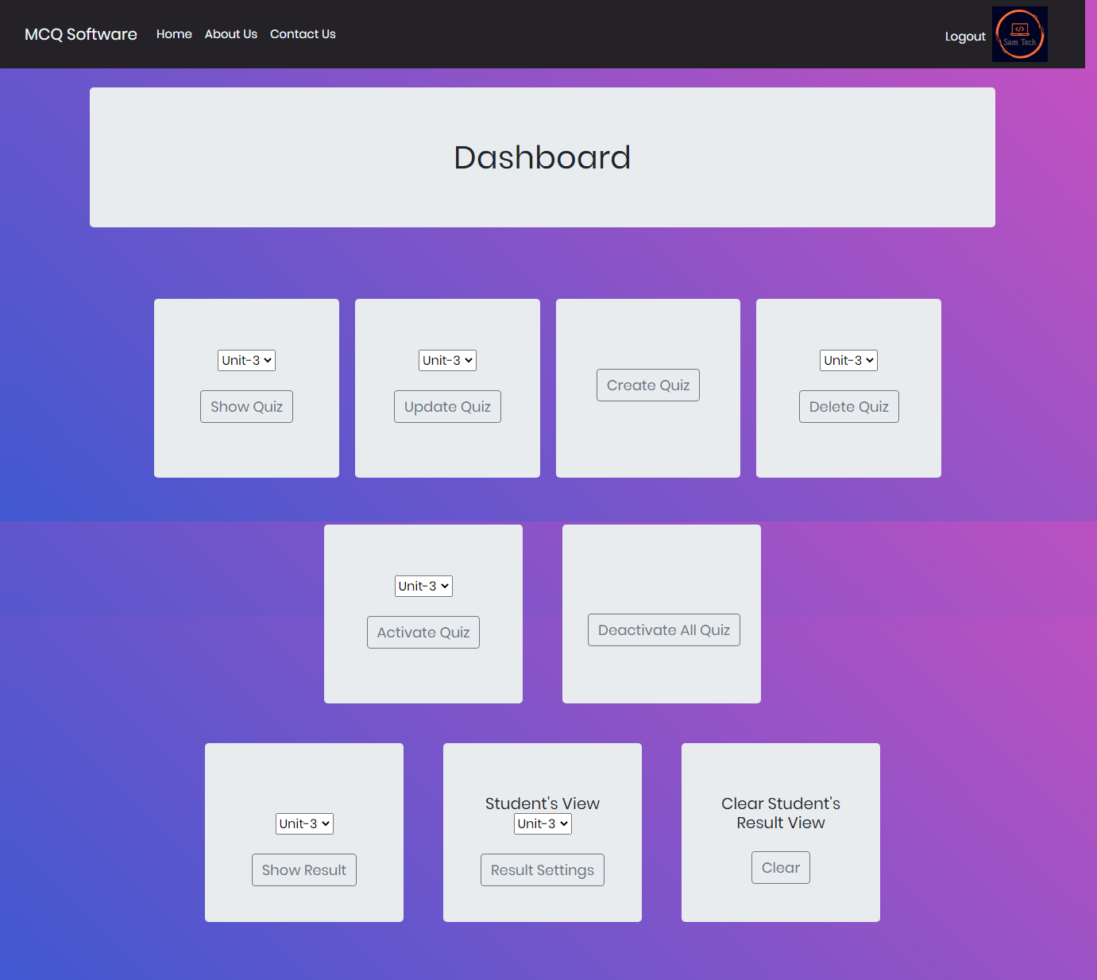

Create Quiz

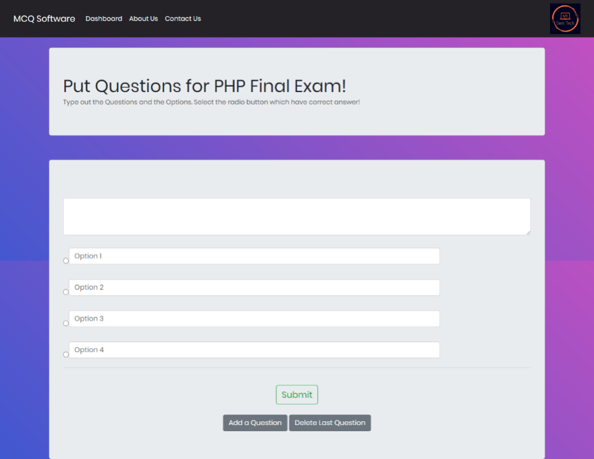

Quiz View for Student

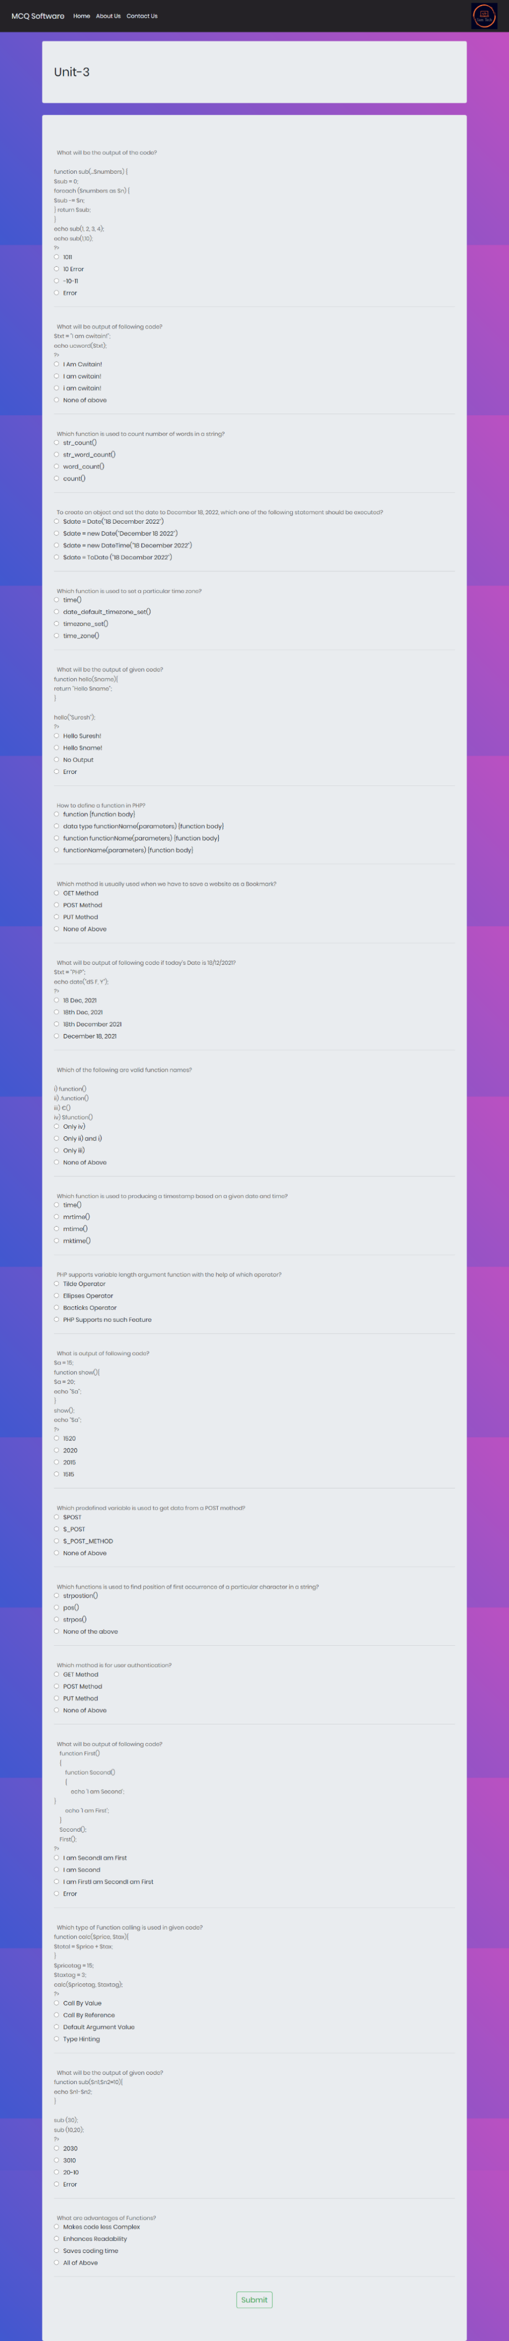

Results

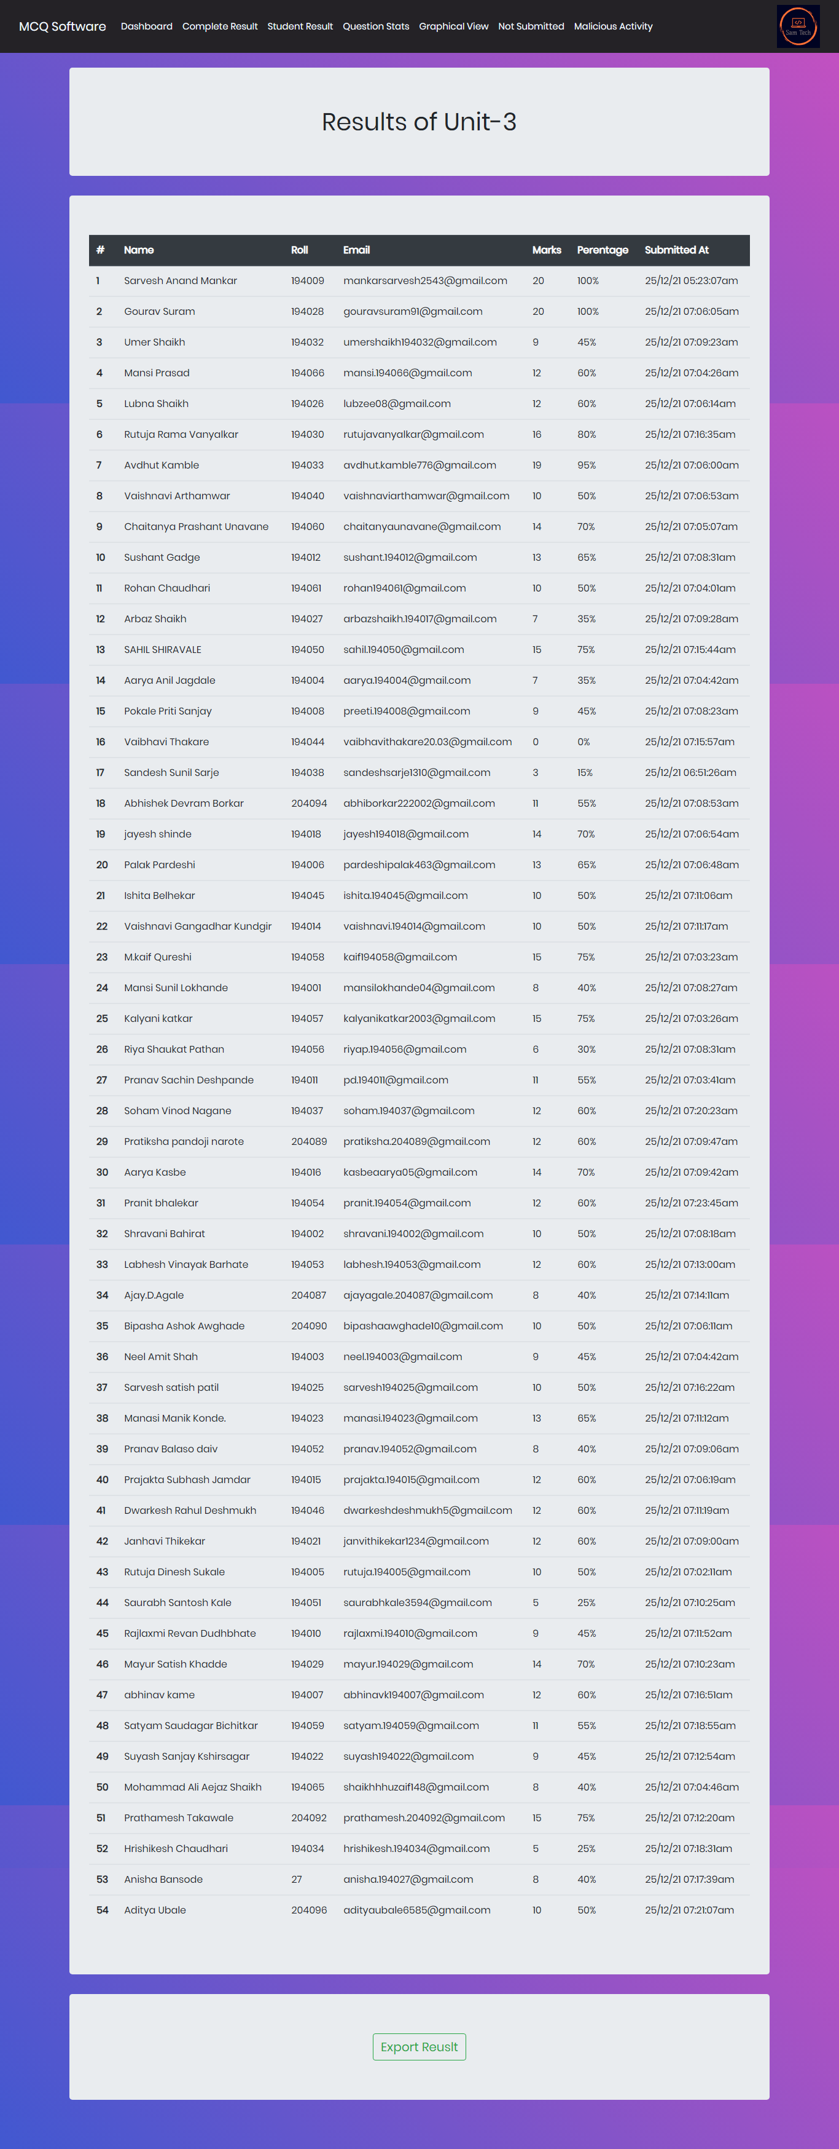

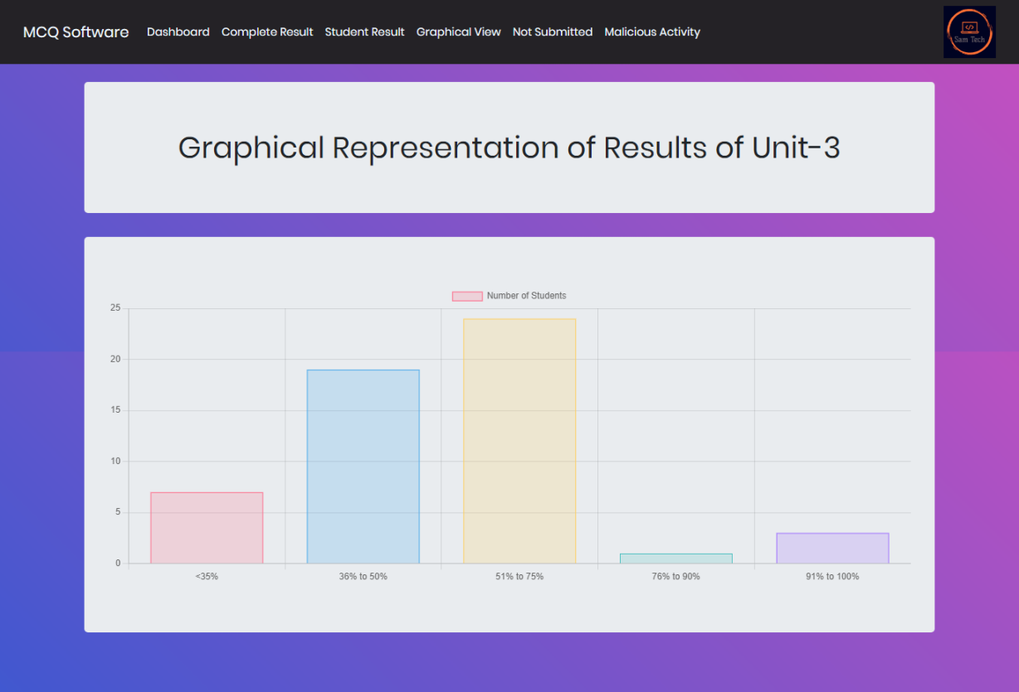

Recording Malpractices Performed By Students

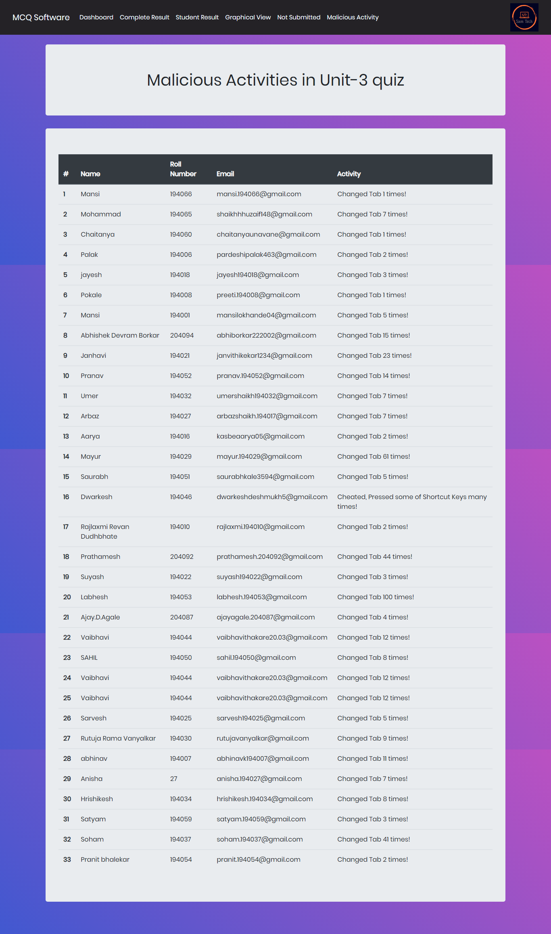

Results View at Student’s Side

